Loudoun County Emergency Medical Services Council, Inc.
Procedures Manual
Junctional Tourniquet
Abdominal Aortic & Junctional Tourniquet (Stabilized)

Background:
The Abdominal Aortic and Junctional Tourniquet – Stabilized (AAJT-S) is indicated for bleeding not amenable to standard tourniquet application. It is a one-time use device that comes in an individually sealed package. The AAJT-S features an easy to use tightening system with the goal of consistent, stable occlusion. The AAJT-S is indicated to control difficult bleeding in the primary junctional areas (inguinal and axillary) as well as the pelvis where proximal compression of vessels is the most effective way of hemorrhage control. The AAJT-S accomplishes this by compressing the descending aorta, at or near the bifurcation of the aorta, the common femoral artery in the groin, or the subclavian artery in the axilla. Human studies show that the device is effective at stopping blood flow at these sites at inflation pressures of 230 mm Hg.

The AAJT-S has a built-in safety to avoid over tightening to decrease the risk of tissue damage. In addition, the AAJT-S has demonstrated the ability to maintain efficacy during patient movement in confined space rescue, drags, and hasty extractions.

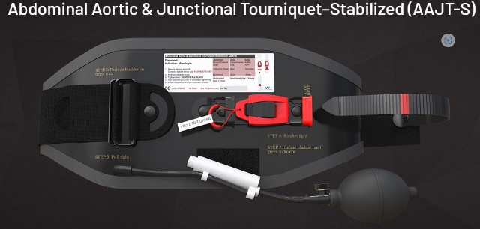

- Potential Indications for use:
  - Severe bleeding in the pelvis, inguinal, and axilla regions.
  - Unstable Pelvis or signs/symptoms of pelvic fracture
  - Bleeding, uncontrolled by another Tourniquet or direct pressure.
- Warnings:
  - Contraindications of use in abdominal placement
    - Known abdominal Aortic Aneurysm
    - Pregnancy
  - Pelvic Fracture Stabilization
    - The bladder is NOT to be inflated

- Performance Indicators:
  - Bleeding is controlled
  - Note the time of placement

- Device Anatomy:
Fully inflated Bladder
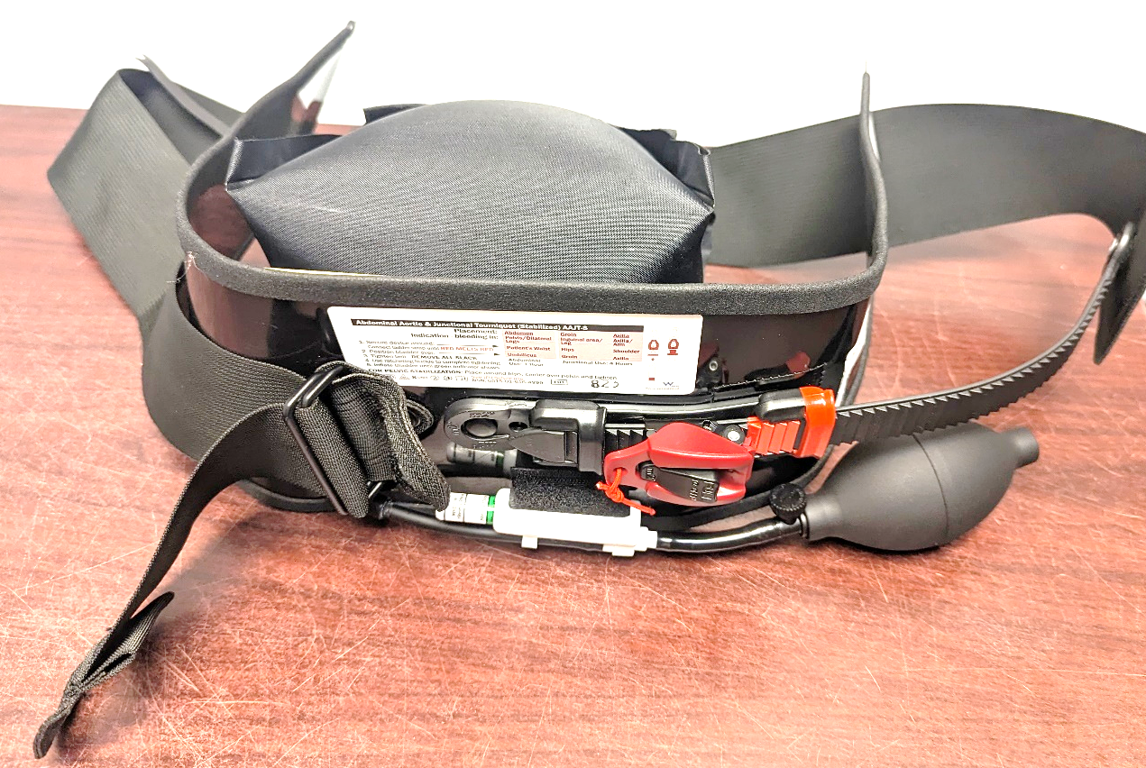
Ladder Strap
Pull here to
remove slack
Thumb here while removing slack
S Inflation Bulb
Air Release
valve
Ratcheting
device
Automatic Pressure release valve
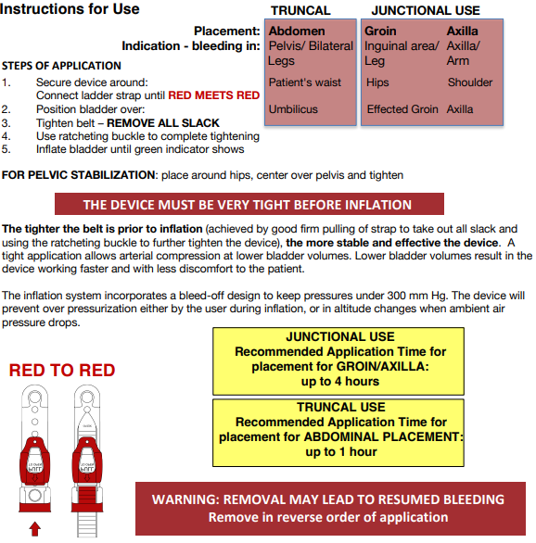

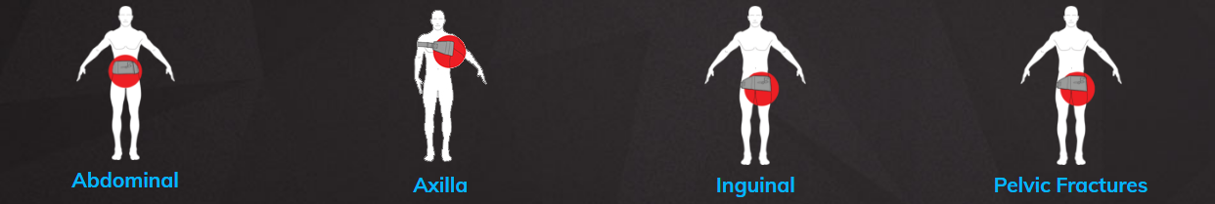

Abdominal application is done by positioning and securing the device bladder over the umbilicus and inflating the bladder.
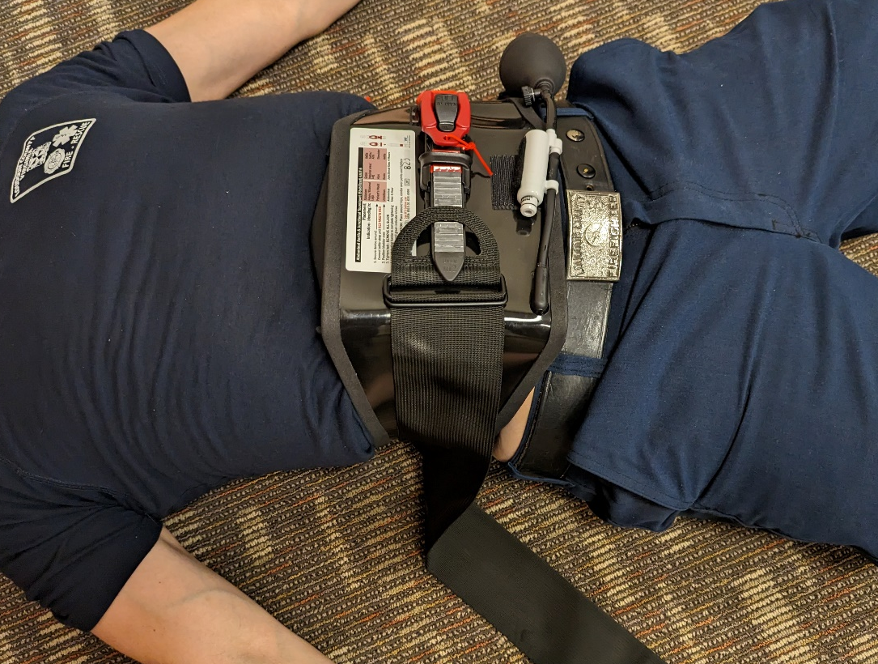

Axilla application is placed high in the axilla with the tension band around the opposite arm. When inflated the wedge bladder applies pressure to the inferior aspect of the axillary and subclavian arteries.
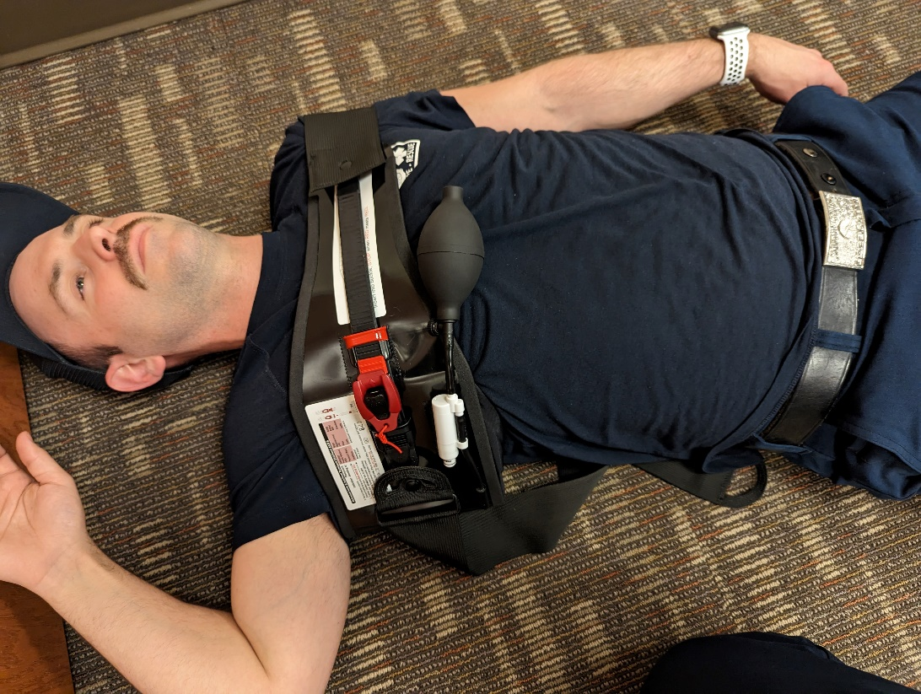

Inguinal application is achieved by securing the device around the hips. Position and secure the device bladder over the affected groin and inflate.

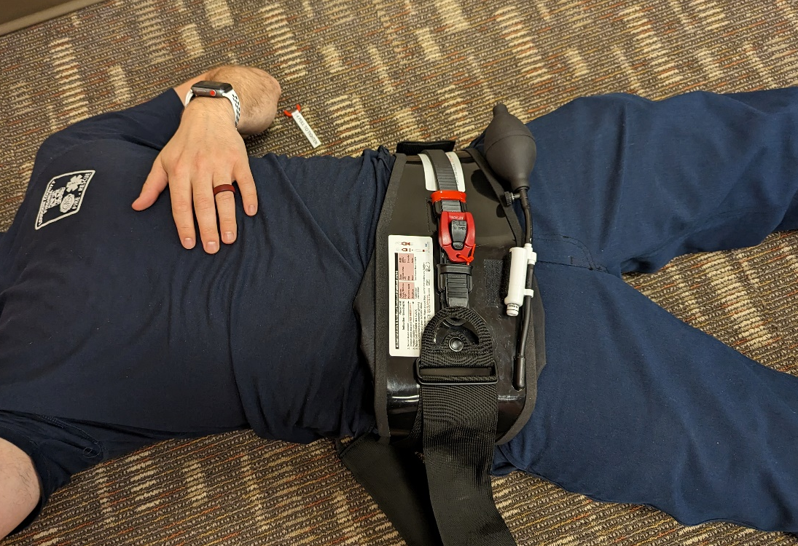

Pelvic fracture stabilization is done by positioning and securing the device bladder over the pelvis, passing over the hips. ***The bladder is NOT to be inflated***.

